Module 11 : LOD Expressions

1. LOD Calculations:
   1. In business, cohort analysis is most often used to study customer retention. A cohort is a group of customers or subjects that have a common characteristic.

Determine the Cohorts by the date at which customer made their first transaction at superstore (The minimum order date per customer will give the first purchase date).

Create a chart showing the Sales of Super store over different years and identify whether longer tenured customers make a larger contribution to sales?

*Hint: Since the data in the view is displayed by year (not by customer), we must use an LOD Expression to fix the minimum order date per customer.*

Output:

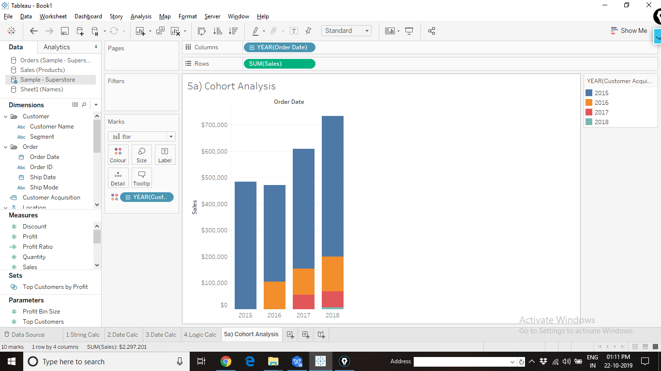

* 1. Display the number of customers in each year from different Cohorts.

Output:

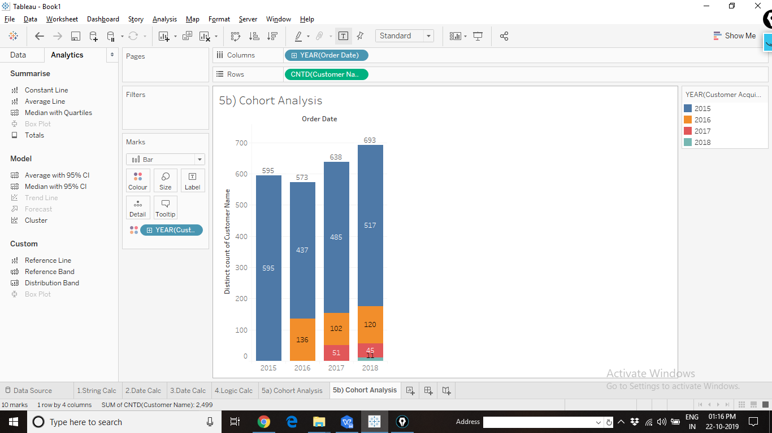

1. LOD for Percent of Total (Absolute): This is the Sales of Superstore for different Categories.

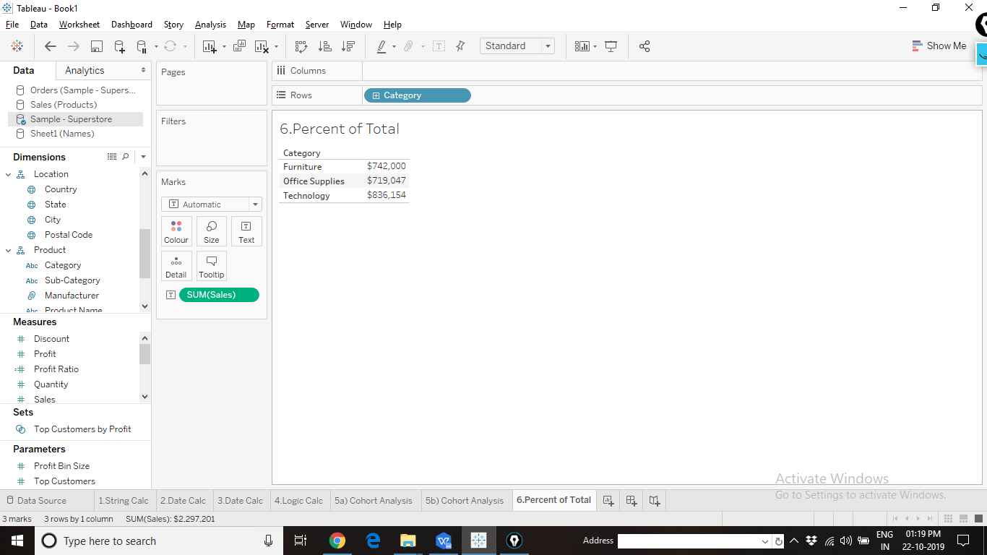

Create a view to Display the Sales as Percentage. The Percentage value should be the Absolute value (not relative), it should not change even when the categories in the chart are filtered out.

Output:

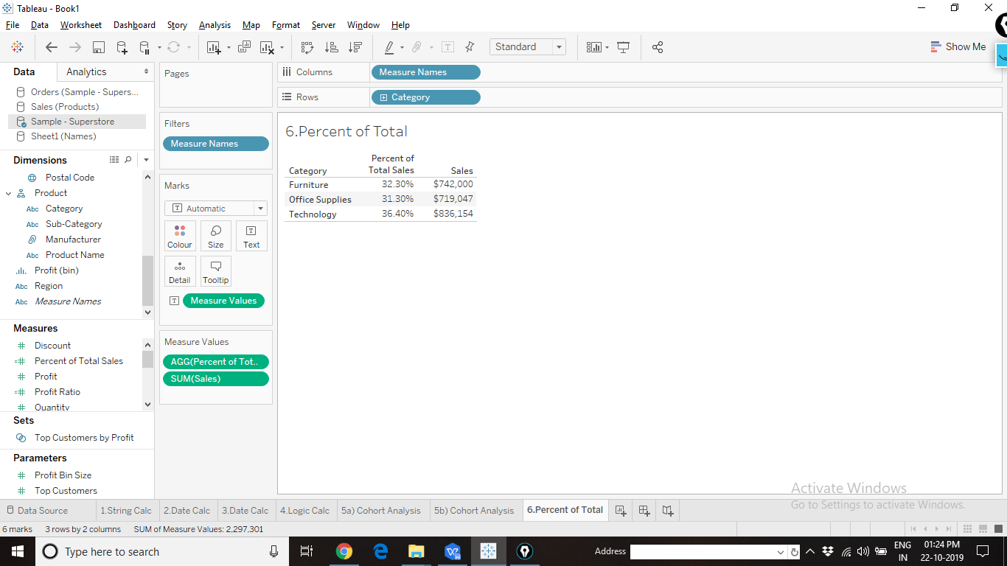

Data does not change even when the filter is applied:

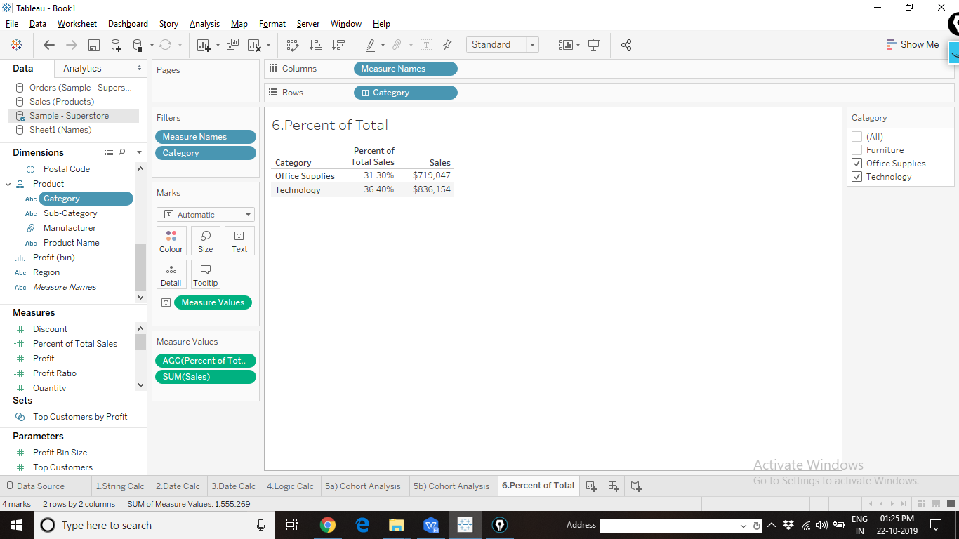

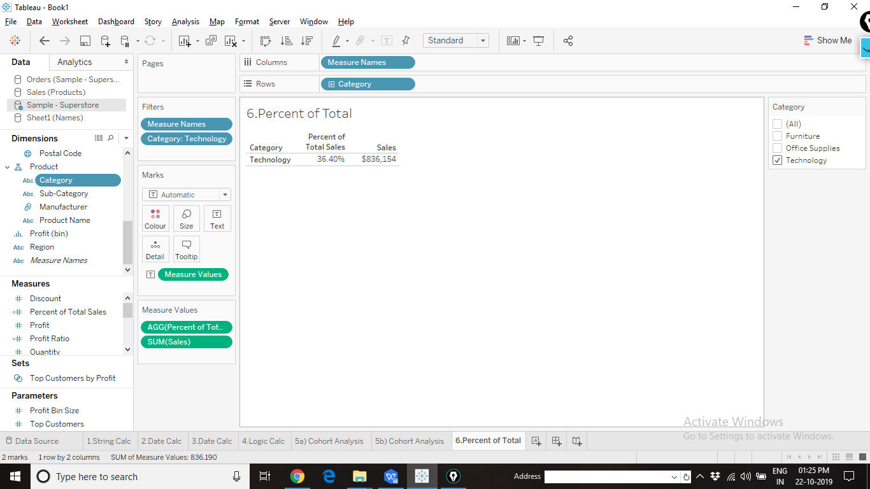

1. LOD Sales corresponding to Maximum Profit: Create a chart to display the Maximum profit from all the customers. Show the corresponding Sales value.

Output:

